What exactly a Biosphere Reserve consists of?
The Edu-BioMed project’s course

Module 2
What a Biosphere Reserve is (and is not!)

[ENGLISH]

About Edu-BioMed
The project aims to strengthen, ameliorate and upgrade academic activity at four Moroccan and Lebanese Higher Education Institutions (HEIs) in the context of Mediterranean Biosphere Reserves (BRs), in collaboration and through networking with BRs’ stakeholders (citizens, visitors, managers and technicians), public administrations and EU Partners.

Partners:
- Universitat Autònoma de Barcelona, Spain (coordinator)
- Université d’Aix Marseille, France
- American University of Beirut, Lebanon
- Université Saint-Joseph, Lebanon
- Université Cadi Ayyad, Morocco
- Université Mohammed V de Rabat, Morocco
- MAB France, France
- Association for the Protection of Jabal Moussa (APJM), Lebanon
- UNIMED – Mediterranean Universities Union, Italy

More at
www.edubiomed.eu

The online version of the course is at:
https://www.edubiomed.eu/mooc/open-web-version-of-the-course/

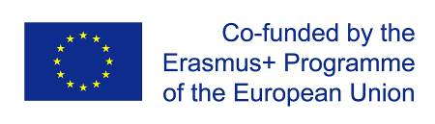 | The Edu-BioMed project has been funded with support from the European Union. This document reflects the view only of the author, and the Commission cannot be held responsible for any use which may be made of the information contained therein.
 | This work is licensed under a Creative Commons Attribution 4.0 International License

Table of Contents

Table of Contents 3
Welcome 4
Whom is the course for? 5
How to use the course 6
Module 2 – What a Biosphere Reserve is (and is not!) 7
M2 - Lesson #1 The Man and Biosphere program (intro) 8
M2 - Lesson #2 The Biosphere Reserve concept 11
M2 – Lesson #3 How to become a Biosphere Reserve? 14
M2 – Lesson #4 The role of Scientific Committees in the management of a Biosphere Reserve 17
M2 – Lesson #5 The Mediterranean region 19

Welcome
What exactly a Biosphere Reserve consists of?
The objective of the Edu-BioMed course is to answer to this key question from a Mediterranean perspective. The course is developed under the framework of the project, whose main objective is to promote education and applied research in Mediterranean Biosphere Reserves.
Throughout the course, participants will learn about the case of Biosphere Reserves, special protected areas promoted under the auspices of the Man and Biosphere Program of UNESCO. Teachers are professionals in the field of environmental protection and education: university professors and researchers, NGOs representatives and Biosphere Reserve managers.
The Edu-BioMed course in numbers:
- 5 modules
- 1 Inspiring Talk
- 28 lectures
- 14 organizations involved
- 22 trainers
- 1 MOOC

Whom is the course for?
The online course “What exactly a Biosphere Reserve consists of? from a Mediterranean perspective” produced within the Edu-BioMed project with the support of the Erasmus+ Capacity Building Programme of the European Union, aims to promote education and applied research in Mediterranean Biosphere Reserves and raise awareness on the management and relevance of the reserves.
The course content is composed of five modules, which explore different aspects related to Mediterranean Biosphere Reserves, exploring the role of the biosphere in an era of global change, and how Biosphere Reserves can serve to the understanding and managing of changes and interactions between social and ecological systems. Managers of the Reserves present case studies from the Med region as well as conceptual and methodological tools that are relevant in the field of conservation management.

Target Audience
The course is addressed to many different targets:
- Students developing skills on biodiversity, nature conservation, biosphere reserves and protected areas, territorial governance and more
- University educators (professors, lecturers) from several discipline, from environmental studies to Mediterranean geography, from sustainable tourism to natural sciences, etc.
- Researchers and professionals in the field of environmental protection
- Representatives and Biosphere Reserve managers, staff and practitioners
- Citizens, associations and the wider public with an interest in biodiversity and natural heritage protection
- Local communities living and working in the Biosphere Reserves
- Decision-makers at national and regional levels

How to use the course
The course is designed as a learning journey for students and adult learners, who can navigate through the 5 modules and the many lectures and resources available. Videos, readings and activities are proposed by the 22 trainers involved in the production and delivery of the contents.
The course can be accessed in both English and French.
The online course “What exactly a Biosphere Reserve consists of? from a Mediterranean perspective” produced within the Edu-BioMed project Course is one of the main outputs of the project. The content and online activities are available under an open license that enables anyone to reuse, adapt, store and share those resources.
The entire course and each one of the modules are available as standalone units of content, so anyone anywhere can repurpose them according to their own needs. To facilitate the use of the course contents, and to support the sustainability of the Edu-BioMed course over time, it has been developed in different formats.

Course Formats
PDF / WORD
The content of the course has been released as both PDF and Word files. The current document is the English version of the Edu-BioMed course.
HTML / Open Web
The open version is accessible through the Edu-BioMed project website: Open Web Version of the Course.

Terms of Use
The Edu-BioMed course contents are licensed under Creative Commons Attribution 4.0 International License.
This means that everyone is free to:
- Share: copy and redistribute the material in any medium or format
- Adapt: remix, transform, and build upon the material for any purpose, even commercially
You may do so for any purpose. However, you must give appropriate credit to the Edu-BioMed project, provide a link to the license, and indicate if changes were made. You may do so in any reasonable manner, but not in any way that suggests the licensor endorses you or your use. Moreover:
- You do not have to comply with the license for elements of the material in the public domain
- The licensor cannot revoke these freedoms as long as you follow the license terms
No warranties are given. The license may not give you all of the permissions necessary for your intended use. For example, other rights such as publicity, privacy, or moral rights may limit how you use the material.
Please contact us at info@edubiomed.eu if you have any questions about citation and attribution.

Module 2 – What a Biosphere Reserve is (and is not!)

- LESSON #1 The Man and Biosphere program (introduction)
Miguel Clusener Godt, UNESCO

- LESSON #2 The Biosphere Reserve concept
Catherine Cibien, MAB France

- LESSON #3 How to become a Biosphere Reserve
Catherine Cibien, MAB France

- LESSON #4 Role of Scientific Committees in the management of a Biosphere Reserve
Juana Barber Rosado, Universidad Politécnica de Madrid

- LESSON #5 The Mediterranean region
Pierre Doumet, Association Protection Jabal Moussa (APJM)

M2 - Lesson #1 The Man and Biosphere program (intro)
Miguel Clusener Godt, UNESCO
Miguel Clusener Godt is the Director of the Division of Ecological and Earth Sciences in UNESCO Headquarters in Paris, and he is the Secretary of the Programme on Man and the Biosphere (MAB), which manages the World Network of Biosphere Reserves.

Description
Miguel Clusener Godt presents an overview of the Programme and the World Network of Biosphere Reserves, including figures, curious facts and his views on both its track record and path ahead.

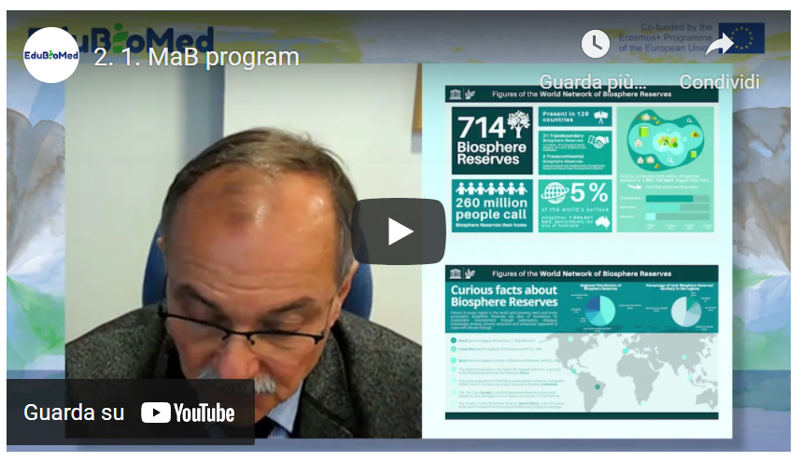
Link to video: https://youtu.be/3CMtpD9UBxE

Activity
Surf Man and the Biosphere (MAB) Programme ( https://en.unesco.org/mab/ ).

Transcript of the video
Hello, ladies and gentlemen, Friends of the Biosphere Reserve, my name is Miguel Clusener-Godt, the director of the Division of Ecological and Earth Sciences and also the secretary of the Man and the Biosphere Program. So, the Man and the Biosphere Program program started in 1971, so almost 50 years ago as a research program, but also as a program of integrating nature conservation and integrating sustainable development for human beings. So those days, it was extremely full participating already.
What became quite normal after the Rio conference in 1992 and also after the most recent events, also taking into account, for example, the results of the Paris agreement and working on climate change issues from the IPBES platform, working on biodiversity conservation. So, the backbone, of course, of the program are the Biosphere Reserves. And you will see on the slides what I am talking about. I will show you two slides. This one is some figures. I will start also showing you on the right side up of the slide what is the bias preserve the core area surrounding buffer zone and surrounding transition area. But today and I say today, it's 2020.
We are now having at the MAB International Co-ordinating Council, which every year designates new sites worldwide. So, we had this year some 25 new sites designated. And our total figure now is seven hundred fourteen Biosphere Reserves in one hundred twenty-nine countries, including 21 transboundary biosphere reserves and two transcontinental Biosphere Reserves. So, these are the raw figures, I would say, on the overall network. So, as you can see, they are spread all over the world. And of course, it's quite important. And this program is not another program just for natural parks or nature conservation. We have a total of more than 200 million people.
In these biosphere reserves. So, it's really a program for the people or people are part of nature and they are not opposed to nature, so they're incorporated in the nature protection, but also in the sustainable use of natural resources. Speaking about the size of biosphere reserves worldwide, imagine we will we pushed them all together, this will give us around five percent of the world's total surface.
So, all together is roughly some seven million square, seven million square kilometers. This would give us around the size of Australia. So, when you hear the figures, 260 million people the size of Australia, five percent of the terrestrial surface of the world, you may have heard that the conventional biological diversity CBD recently declared that the Decade for Biodiversity Conservation 2020-2030 and suggested 30 percent of the terrestrial area protected, 10 percent strictly protected. So, this is the target. I think it's a very good target and we are all called to participate in that. However, I must say that the program is, of course, participating in this for quite a long time now and that we have, as I already mentioned, five percent of the terrestrial size of the world protected and one point five percent strictly protected as national parks. So, we are still far away from that target, and I think it's quite important. When you see also on the right down side of the slide, the distribution of this surface in different zones.
So, you see a big transition area and slightly smaller buffer zone, even smaller core area. These, of course, the tendencies on the program, let's say, for the last 15 more or less before always, the core area was more dominating. So, this give you just a roughly a rough overview, what we are talking about and concerning also. Some curious facts would come to the second slide and to give you an overview, for example, where these areas are distributed, for example, you see that the regional distribution of biosphere reserve is mostly in the Europe and North American area. However, you see the total size of the biosphere reserves, the area that covers most is, of course, Latin America.
You see the pilot on the right side, just to give you some curious facts also, because we will we will often ask, what is the minimum size? What is the maximum size? Does this exist? So, first of all, I would say these biosphere reserves are represented in all ecosystems of the world. They are covering all parts, whether high mountains, savannas, islands, coastlines, peri urban areas. So, they are all present. And when you see, for example, point number one, the biggest size, this is Brazil, more than one point seven square kilometers. This is, of course, the midatlantic biosphere reserves that goes over three thousand five hundred kilometers.
But some other curious figures, Costa Rica, more than 50 percent of the national territory is a Biosphere reserve. So, a truly development plan for the country. Now we are coming to Spain.
Spain has the biggest number of biosphere reserves: 52. They are, of course, not so big, but they are spread all over the place as useful models for nature conservation and sustainable development. But also, some of the emblematic figure on board, for example, the Mount Everest in China is in the along the borders of Qomolangma biosphere reserve, and I'm coming more to the part of protecting the entire population of the highly endangered Sumatran Orangutan. And we are just talking about more than 6000 individuals, which is not very big. And living all together in the Gunung Leuser Biosphere Reserve of Indonesia. What does it mean? It means that if we don't have one day as far as we can, sure, we will not have these big ape species. And I think there we are touching already at the border of feasibility and the border of real need.
But also, who are managing these reserves? We hear a lot that national governments.
In Spain, for example, autonomous communities or mayors, but the Tsa Tue in Canada is the first Biosphere Reserve in the world managed by what they call first nation indigenous population. It's entirely managed by an indigenous group. And the last figure I just wanted to show you to give you an overview on the program is, of course, the poorest class diasporas in South Africa, which is the only place in the world where we have three recognized biodiversity hotspots coming together. So, again, something that is for nature protection, very important, but also existing in a highly populated area, because the whole cluster of biosphere reserves is really where a lot of people are living and where we, again, feel that we are really touching exactly the border between the people living in the area and the conservation of what could be done. Would like to give you some words why this is so important and why this has become even more important due to the covid-19 crisis.
Human population is going up. Nature. “Wild” nature, in inverted commas, is pushed. In his borders. And we are coming to a close, we are coming very close, closer than ever been and zoonosis I mean, pandemic coming out of situation, jumping over viruses, parasites to human beings is a lot fact due to these condensing and misusing of natural spaces. So, what we need and I think the Secretary-General of the U.N. mentioned it personally recently at the biodiversity meeting in New York. We need more of these areas with bigger areas. We should really go for the target. But for the sake just to be with the target, for the sake is, of course, that our entire planet managed in a sustainable way, that we get protected areas large enough to guarantee also for large most, for example, or for large animal populations, the required space to live well, also for us to produce what we need, agriculture, agroforestry, forest products. But we need also leasure we need also what in latin America is called ‘buen vivir’, good living for the world population.
And I think this is the challenge. I hope this MAB program, and I'm proud to be the secretary of this MAB Program can make a substantial contribution. As you heard from the first slide that I showed you, we have right now one hundred and twenty-nine countries on board. So globally speaking, still some 70 countries missing. I would hope they'll get them soon on board with a biosphere reserve proposal, at least one, so that we can really say we have the entire world community on board.
So, it was just a brief introduction for you, for your project, for your seminar, for your work in protecting biodiversity, but also in assuring at the same time the integration with sustainable development.
So, thank you very much for listening to me. Thank you very much for your interesting and UNESCO's Man and the Biosphere program. And looking forward to all your contributions in the future for this interesting program. Thank you very much.

M2 - Lesson #2 The Biosphere Reserve concept
Catherine Cibien, MAB France
Catherine Cibien is the Director of MAB France. MAB France animates and strengthens the national network of 14 Biosphere Reserves, puts it in touch with the French and international communities interested in this program: scientific community, educational and academic world, organizations for the management and conservation of biodiversity, sustainable development and of the ecological transition. She co-hosts the Master MAB (Man and Biosphere) at the University of Toulouse.

Description
Ms. Catherine Cibien explains what a Biosphere Reserve consists of.

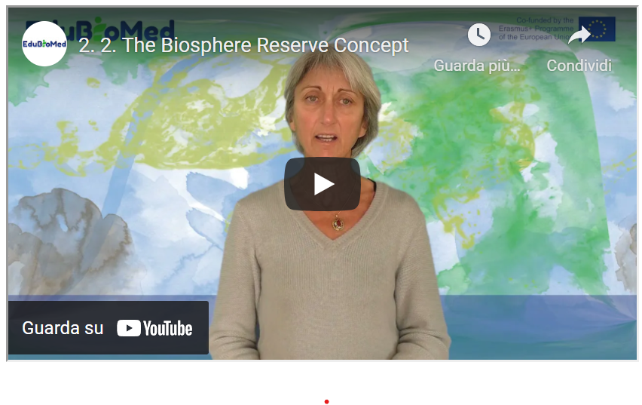
Link to the video: https://youtu.be/RK4FUadOsDc

PPT Presentation
Link to the slides: https://www.edubiomed.eu/wp-content/uploads/2021/09/PPT-Biosphere-Reserve.pdf

Suggested Reading
50 ans d’histoire du Programme MAB (l’Homme et la Biosphère) de l’UNESCO.
Transcript of the video
The UNESCO Biosphere Reserves are designed to experiment and implement sustainable development approaches in territories, and thus take up fundamental challenges currently facing humanity, both the rapid loss of biodiversity and the challenge of climate change.
They were set up under the auspices of a programme, MAB Man and Biosphere, launched in 1971. The MAB is looking for solutions to manage our resources more rationally. The RBs are sites for experimentation. They contribute to the UN 2030 agenda, to the implementation of sustainable development goals, It is a question of experimenting in BR, then inspiring beyond that, on practices, uses and management methods that have proven their effectiveness.
The first biosphere reserves date back to 1976. At that time, the criteria governing them had not yet been defined. They were built up little by little and were formalized in 1995 at a conference held in Seville, Spain. From this conference emerged the Seville Strategy and the Statutory Framework for the Global Network, which are still the framework documents for the BRs today.
The Seville Strategy defines the main objectives of the biosphere reserves and proposes recommendations to be implemented both at the international level, at the national level and at the level of each reserve, since in fact it is a question of acting at all levels of decision-making to guide policies and to put them in synergy. In the direction of sustainable development. The statutory framework of the World Network sets out the procedure and criteria for designating new biosphere reserves. This document explains what a biosphere reserve is and how it should function.
A biosphere reserve must fulfil 3 functions, 3 complementary, equally important and interconnected functions. The first concerns the conservation of natural diversity, of biodiversity while respecting cultural values, which means that biodiversity will not be conserved in the same way in Europe, Africa or Asia and that it will be adapted to the needs and cultures of the territory in which the biosphere reserve is set up. The second function of BRs is a sustainable development and land-use planning function. The 3rd function is called logistical support: this concerns research and scientific monitoring programmes to understand and monitor the territory, and education training raising awareness among inhabitants, stakeholders and visitors with a view to capacity building. which will help to achieve this delicate balance between conservation and sustainable development. 2 ideas to keep in mind: a balanced approach to conservation and development and the idea of better knowledge for better management.
Each biosphere reserve must be zoned with 3 types of zones. Core areas, areas protected under the law of the country in which one is located, where biodiversity is protected by legal means, in the long term. Buffer zones, to increase the effectiveness of core area conservation, around each core area: these are often public lands, areas where human activities are controlled in a reasonable manner. Around the core areas and their buffer zone is the transition/cooperation zone, where the towns and villages are located, where all human activities take place and where most of the development or support programme for human development will take place.
Each biosphere reserve must be large enough to be a real demonstrator of sustainable development approaches: the size will depend on the context: in the mountains, in a large homogeneous landscape or on an island, for example, the constraints and challenges will be very different in terms of development, biodiversity and management.
The Seville strategy and the statutory framework place particular emphasis on governance issues: each biosphere reserve must have an open governance system that will associate public interests, local communities and also private interests, both in the construction of the biosphere reserve project and in its implementation; in other words, there must be active local participation to establish and maintain a biosphere reserve because there must be a clear commitment to the project.
Each reserve must have a management policy or plan. That is to say, a document on which people have agreed and which concerns their territory for the years to come. This management policy must be supported by an authority and be endowed with human and financial resources so that it can be implemented.
Today there are 714 Biosphere Reserves in 129 countries. This large network shows that the biosphere reserve concept has the flexibility to adapt to a very large number of geographical, ecological, socio-economic and cultural situations. It has been set up in many regions of the world, and the World Network of Biosphere Reserves today constitutes a global cooperation mechanism and a large library of good practices and case studies in the field of sustainable development, and as such they can inspire the rest of society to face the current challenges we face.

M2 – Lesson #3 How to become a Biosphere Reserve?
Catherine Cibien, MAB France
Catherine Cibien is the Director of MAB France. MAB France animates and strengthens the national network of 14 Biosphere Reserves, puts it in touch with the French and international communities interested in this program: scientific community, educational and academic world, organizations for the management and conservation of biodiversity, sustainable development and of the ecological transition. She co-hosts the Master MAB (Man and Biosphere) at the University of Toulouse.

Description
Ms. Catherine Cibien explains the steps for a territory to become a Biosphere Reserve.

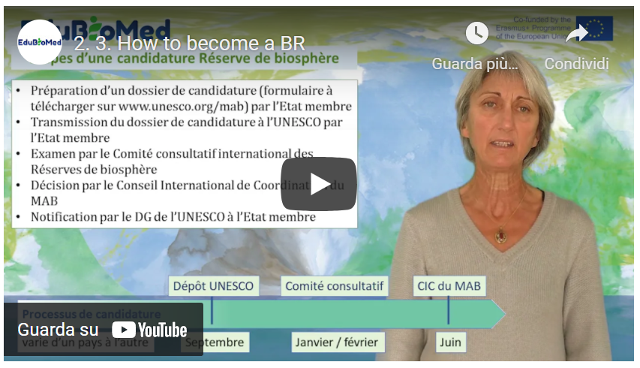
Link to the video: https://youtu.be/F7bpQErVVzg

PPT Presentation
Link to slides: https://www.edubiomed.eu/wp-content/uploads/2021/09/PPT-CAPSULE-2.3.pdf

Further Readings
- Technical guidelines for biosphere reserves
- Establish a Biosphere Reserve
- What is a Biosphere Reserve?
- The MAB Programme of the UNESCO

Transcript of the video
What steps must a region go through to be designated by UNESCO as a biosphere reserve and which bodies will be involved in order for a site to become part of the world network of biosphere reserves?
First of all, let us remember that UNESCO is a United Nations agency, where Member States are represented.
BRs are established under the auspices of UNESCO's Man and the Biosphere (MAB) programme. The secretariat of MAB is provided by UNESCO's Division of Ecological and Earth Sciences. The main international governing body of MAB is the International Coordinating Council, which is composed of representatives of 34 Member States. The representation of geopolitical regions is balanced. This body generally meets once a year and approves new biosphere reserve designations. It also approves periodic reviews of existing biosphere reserves, which take place every 10 years. The ICC appoints a Bureau, a lighter body. Another expert body, the International Advisory Committee, examines biosphere reserve files from a scientific and technical point of view. These experts, also from different regions of the world, are appointed by the Director-General of UNESCO.
Each biosphere reserve, in order to be recognized, is subject to a nomination process. The Member States submit the candidatures through diplomatic channels, through their Permanent Delegation to UNESCO. Let's recall the steps involved in applying for a site to become a UNESCO biosphere reserve. A file is to be filled in according to a form that everyone can find on the UNESCO website in French, English and Spanish and which can be downloaded in Word or PDF format. It aims to collect a set of information on the site and to ensure that it fulfils the 3 functions and the criteria required to become a BR, namely those described in the Statutory Framework of the World Network of BR of 1995.
The process prior to the application varies in its organization from country to country and can take several years. Once this candidature process is completed, the file is transmitted to UNESCO by the Member State. Each year, countries can submit files to UNESCO before the end of September. Each file will first be checked by the secretariat, which will make sure that all the documents are there, that nothing is missing. Then it will be examined by the technical body, the international advisory committee, this committee of experts who will check that the proposed site meets the criteria of the statutory framework. The advisory committee will make recommendations either to approve the biosphere reserve, or to refuse it, or to approve it on condition that additional documents or clarifications are provided by the member state, which has a few months to do so. The applications and clarifications made, or not, are then examined by the Bureau of the MAB Council, which proposes the sites for designation, proposals that are validated by the MAB International Coordinating Council, generally in plenary session. The MAB ICC usually meets in June/July, which means that it will have taken almost 10 months for the file to be processed within the framework of UNESCO.
So, let's go back to the process of submitting candidatures to UNESCO: how does the candidature process take place in the country, and who does what? It depends on the country and I will take two examples, France and Morocco.
In France, the French MAB committee has chosen to support applications from territories that wish to become a biosphere reserve. The initiative is therefore generally local, and may come from associations, researchers or elected representatives. The first step in the application process is a declaration of interest from the territory to the French MAB committee. It will be examined and encouraged if the proposed territory is likely to be able to meet the BR criteria. If this is the case, the deliberation of a local authority or administrative structure bearing the candidacy is requested, as well as membership of MAB France. A whole consultation process is then set up at local level. The application file is studied by MAB France, which will only forward it to UNESCO via the Permanent Delegation when it is deemed appropriate, in order to fulfil the statutory framework and functions expected of a BR.
The MAB France committee attaches great importance to the concertation stages prior to the establishment of the biosphere reserve and proposes that an information phase on the important project be carried out: a website, press articles, public meetings will help explain to the population what a biosphere reserve is, what it will be used for, what its outlines could be, and what role people can play in this process.
The second stage is that of appropriation: it is therefore a question of answering all the questions that arise so that the stakeholders understand the interest, what the biosphere reserve can bring them. Then, a process of co-construction of the project begins: what are the challenges facing the territory, how will the biosphere reserve enable them to be met, what are the priority subjects, who are the stakeholders concerned, all these points will be debated in the villages and towns and will enable the biosphere reserve project to be built. This project will take the form of a management document.
Morocco has another way of proceeding. In Morocco, in the 1980s, it was a question of involving the regions in the dynamics of sustainable local development and promoting them. The biosphere reserve will contribute to the fight against soil degradation, desertification, poverty and the loss of biodiversity. The choice made by the Moroccan state is to work on the scale of traditional production systems, such as the argan grove, for example, which concerns the distribution area of the argan tree, a tree to which very ancient uses are linked. The same applies to palm groves, which are places of great heritage interest. These places present a diversity and originality of land use. Biosphere reserves are established on the scale of regions that have a particular wealth or character. It is also a question of integrating networks of protected areas, a diversity of land use and sites of heritage interest into a vast territory in a sustainable development perspective. It is the Moroccan State, through the Department of Water, Forests and Agriculture, which initiates and presents the dossier to UNESCO. The work of collective appropriation takes place after the designation of the biosphere reserve.

M2 – Lesson #4 The role of Scientific Committees in the management of a Biosphere Reserve
Juana Barber Rosado, Universidad Politécnica de Madrid
Juana Barber Rosado is a forestry engineer from the Universidad Politécnica de Madrid and works in the administration of the Barcelona Provincial Government as Head of the Natural Parks Technical Office. Since 1992 she has been working for the Natural Park Service of Barcelona Provincial Council, first as an engineer in charge of building projects at the Central Services and, from the end of 1995, as head of the Building Unit at the Montseny Natural Park and Biosphere Reserve. From mid-2004 to early 2018 she was the director of the Montseny Natural Park and Biosphere Reserve and since 2018 she has been the head of the Parks Office but she still manages the Biosphere Reserve.

Description
The capsule provides an overview of the role of scientific committees within the MaB program and its synergies with the management bodies of a Biosphere Reserves.
Link to the video: https://youtu.be/4cY8ieJbE_Y
Activity
Reading about the International Advisory for Biosphere Reserves from the UNESCO and the related Statute.
Transcript of the video
If we consider the three objectives of a Biosphere Reserve: the conservation of natural and cultural heritage, the sustainable development of peoples who live in these territories and the logistic support.
The meaning of the latter is always difficult to understand, especially for us here in the Spanish Network [of BRs], maybe because of the literal translation from English of the term, but in exact terms, on what the logistic function draws the attention is on the fact that Biosphere Reserves are ‘laboratory spaces’ sites where sustainability models might be tested, models where sustainable development of peoples should be compatible with conservation that is, this third function [of a BR] comes in support to the first two objectives to be met.
It is in this third objective - the logistic support in laboratory spaces - where [scientific] research has a very relevant role. Given the importance of the role - [scientific] research cannot be performed by whom is managing the territory. Management is hard, sometimes: the day-by-day is very complicated, so people who are in charge of managing the territory cannot be the same who conduct scientific activity
Is here where the union between management and the academic entourage becomes crucial and this is what should be stressed: it is very important for a Biosphere Reserve manager -to make the right decisions- to know what is exactly going on in their territory, on a scientific base the Scientific committees play such a role there in Countries where Biosphere Reserves exist.
For example in the case of Spain, a Scientific Committee exists within the Spanish Network of Biosphere Reserves, and it is multidisciplinary, as it can only be because in a Biosphere Reserve, with the previously mentioned objectives, the range of issues you have to deal with is very vast: not only we are speaking about biodiversity protection; not only we are speaking about local development in its broad meaning -related to a rural environment: so to agricultural, forestry issues, but we are talking of many other things: of employment, of social issues, of everything that happens in that territory. Therefore, the existence of a Scientific Committee multidisciplinary that works together with managerial actors is a successful model towards which we should aim everywhere there are Biosphere Reserves.
I’d like to bring the example of what has been done in the case of the Spanish Network of Biosphere Reserves and its indicators system. A system of indicators was built in collaboration between managers and academics, so to understand if the Biosphere Reserves were complying with their objectives in the accomplishment of the Seville strategy and the Lima Action Plan. Why?
Because UNESCO is periodically evaluating [the BR] every 10 years. But obviously, if after 10 years of work, they tell you that you are not doing a good job, that would be discouraging but if you perform monitoring along these 10 years by yourself - in collaboration with a Scientific Committee- you can more easily evaluate independently where you should intervene, where you should put more resources, or what direction you should take.
So, I believe this is important and it has been an effective approach in Spain and was satisfactory in terms of the periodical evaluation.
Finally, this Scientific Committee is obliged to provide a return back to society, in the territory that is the object of study. It is very important that we start to work on what is called ‘citizen science’. That is because people should gain awareness of their territory, for this territory be a successful Biosphere Reserve and to get awareness, it is important to know what is happening. And who else but the Scientific Committee is best suited to return the results of their analysis back to society? I strongly believe it is very important to have a Scientific Committee in any Biosphere Reserve.

M2 – Lesson #5 The Mediterranean region
Pierre Doumet, Association Protection Jabal Moussa
Pierre Doumet is the Director of the Association Protection Jabal Moussa (APJM) – MBA and a Chemical Engineering degree. He is a founding member and currently the president of APJM. Although a volunteer position, Pierre dedicates more time and effort in managing APJM than he does on managing three other companies which he directs. Renowned for his pioneer work in the private sector, Pierre brought the professionalism and focus of the private sector to the not-for-profit domain of APJM. Under his management, Jabal Moussa, designated a Biosphere Reserve in 2009, became one of the most important ecotourism destinations in Lebanon, receiving an exponentially growing number of visitors every year.

Description
Pierre will tell us stories and tales about Mare Nostrum…!

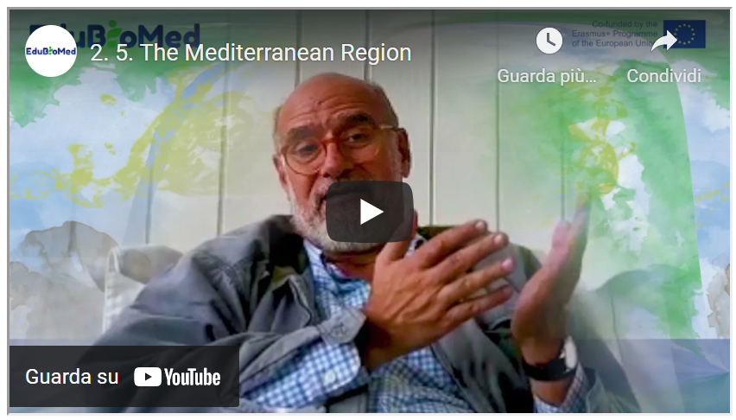
Link to the video: https://youtu.be/VuLw9No3A0Y

PPT presentation
Link to the slides: https://www.edubiomed.eu/wp-content/uploads/2021/09/PPT-presentation-2.5.pdf

Activity
Watch “A Walk with the Expert” ( https://youtu.be/64-at1ZeJ9U ) and “Who Were the Phoenicians?” (https://youtu.be/-X4WtUwaPsA ).

Transcript of the video
Hello, my name is Pierre Doumet and I'm a Mediterranean. Actually, I believe that my ancestors originated from one of the three city states on the far eastern shore of the Mediterranean. Tyre, Sidon or Byblos.
Those guys were traders and they traded all over the Mediterranean and they set up counters everywhere, but they weren't just that. It is said that they invented the simplified alphabet that allowed them to trade more effectively.
And if you look at some of the mythology, it's pretty interesting, for example, to focus on the two children of King Agenor of Tyre and his wife, Telephassa. Their kids were Cadmus and Europa. Cadmus was the first hero in Greek mythology, and he was the founder of the Greek city of Thebes.
He introduced the Phoenician alphabet to the Greek.
And what was he doing so far away from his homeland in Tyre? What was he doing in Thebes? What he was looking for his sister. His sister was called Europa, Europe from where Europe's name originated and his sister was seduced by no less than Zeus himself, transformed into a very tame white bull who took her away. So, everybody was looking for her. But actually, where they were where they had eloped was to the island of Crete. And there they had a child called King Minos and the Minoan civilization started right there.
So, between Cadmus, funder of Thebes and the foundation of the Minoans civilization and the name Europe are coming from a princess of Tyre. What we can see here is that the Mediterranean is a is a place where many civilizations have just been together, worked together or originated one from the other. And this is my purpose today to call for a little bit of this incredible richness of our cultural heritage. So, let's talk a bit about the next phase, … I'd like to show the island of Sicily about 500 years before Christ.
You can see the map right there.
And on that map, you have an island divided between colonies from Phoenicians, Carthaginians, Greek and Ionians. So there, too, you have this incredible mix of civilizations. Let's go further. Let's go into about 100 hundred years after Christ.
We have the Roman Empire. We focus on the Mediterranean and the sea. The Mediterranean Sea is called by the mighty imperial or Mare Internum, or Mare Nostrum which is a great name. And we should all call the Mediterranean Mare Nostrum: Our Sea. My goal is to see this, that there is an incredible wealth, of cultural wealth in the Mediterranean and here we're talking. Not just of archaeology and history, of course, we should be focusing on all the other cultures of wealth like wine, olives and food, song, dance, theatre... all the rest.
As a matter of fact, you hear a lot about the division of north and South North rich – South poor. Of course, I'm not concerned from the far eastern part of the region. But I would have to say that in the Mediterranean, we are all rich.
All of us are so rich with heritage and culture. And one more thing: nature. Nature, I don't know if we all are aware of that. And we are the third richest hotspot for plants in the world in the Mediterranean, 25000 species and one of the most important areas on earth for endemic plants and mammals: there are almost 300 species of mammals in the hotspot in the Mediterranean hotspot, 38 of which are terrestrial endemics birds, 534 species, 63 of which are endemic reptiles, amphibians, it goes on and on. So, let me say again, north and south, east and west, the Mediterranean is so incredibly rich, but unfortunately, it is on the verge of risking to become very poor because it might use it might be losing a lot of its cultural wealth, and more importantly, its natural wealth. There's a lot of species being extinct in the Mediterranean.
There's a lot of loss of habitat. And so, what can be done about that?
This is my purpose basically today is to discuss a little bit the Man and the Biosphere Program of UNESCO. Before I do that, I want to discuss another UNESCO program that's maybe even better known than the Man in Biosphere program is the World Heritage Sites Program. Now, that is where we take a very important site and the fence around it , or we put a wall around it and shut it down, and then we let people come and visit one by one and some nice concept and we preserve the site.
But does it really involve the people around? Does it bring them into the concept?
And here the Man and the Biosphere concept, which is about 50 years old, but I would say is more relevant even today than when it was invented. The man and biosphere put man humans in the middle of the conservation concept. It's a concept where we say we have to preserve nature and culture.
We have to do a lot of research to discover the incredibly rich richness and wealth that we have.
But we have to involve local human beings into activities that are remunerative, that are socially, economically useful to them, that can increase their standard of living. And of course, these have to be sustained over time. So, we call it sustainable development. Might be a word that's been overused, but that is the purpose to have the human being at the heart of conservation. So instead of having a protected area where we put like a box or a belt all over the place and we don't let people in and that's how we protect it, that's not the way we do know. What we have to do is a protecting area, an area that protects nature, protects the birds and the bees and the plants and the forest and the human beings, both the human beings living inside the area. And then they have a vested interest in continuing to protect. And those who visit all of these are inside of a protected area. And that's the Man and the Biosphere concept that I'm talking about. And that concept, I am working with an association called the Association for the Protection of Jabal Moussa, which is one of two very active biosphere reserves in Lebanon. And this is what we try to do.
Now, my purpose today was to discuss the Mediterranean. And so, I'll show you one more chart.
And that chart shows you something called the MedMAB, the Mediterranean Biosphere Reserves. And those biosphere reserves are linked into a cluster that's relatively recent. Previously, we had the AfriMAB , the ArabMAB , the EuroMAB and the IberoMAB and the Asian and Pacific MAB. Now, those are clusters that are started long years, many years ago, and that are forming this MedMAB and showing you is something that we started on an informal basis that we are trying to establish. And that would bring together the incredible cultural and natural wealth of the area into an organization or a sub organization or to at least a link between biosphere reserves that have a lot in common, culturally and naturally, as we already discussed, that hopefully as if you have a future in terms of both conservation and development.
Thank you very much for your attention. We will later talk about in a next video about what has been achieved or was being achieved or what is being tried to achieve in Lebanon in the local biosphere reserve. Thanks.

https://www.edubiomed.eu/?page_id=1620
https://www.mab-france.org/workspace/uploads/mab/documents/histoire-du-mab.pdf
https://unesdoc.unesco.org/ark:/48223/pf0000375692
https://www.mab-france.org/fr/les-reserves-de-biosphere/etablir-une-reserve-de-biosphere/
https://www.mab-france.org/fr/les-reserves-de-biosphere/vous-avez-dit-reserve-de-biosphere/
https://www.mab-france.org/fr/le-mab-unesco/le-programme-mab-de-lunesco/
http://www.unesco.org/new/en/natural-sciences/environment/ecological-sciences/biosphere-reserves/advisory-committee/
http://www.unesco.org/new/fileadmin/MULTIMEDIA/HQ/SC/pdf/sc_mab_IACBR_Sept2011_ENG.pdf

