What exactly a Biosphere Reserve consists of?
The Edu-BioMed project’s course

Module 3
How Biosphere Reserves contribute to understanding and managing changes and interactions between social and ecological systems

[ENGLISH]

About Edu-BioMed
The project aims to strengthen, ameliorate and upgrade academic activity at four Moroccan and Lebanese Higher Education Institutions (HEIs) in the context of Mediterranean Biosphere Reserves (BRs), in collaboration and through networking with BRs’ stakeholders (citizens, visitors, managers and technicians), public administrations and EU Partners.

Partners:
- Universitat Autònoma de Barcelona, Spain (coordinator)
- Université d’Aix Marseille, France
- American University of Beirut, Lebanon
- Université Saint-Joseph, Lebanon
- Université Cadi Ayyad, Morocco
- Université Mohammed V de Rabat, Morocco
- MAB France, France
- Association for the Protection of Jabal Moussa (APJM), Lebanon
- UNIMED – Mediterranean Universities Union, Italy

More at
www.edubiomed.eu

The online version of the course is at:
https://www.edubiomed.eu/mooc/open-web-version-of-the-course/

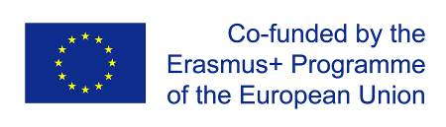 | The Edu-BioMed project has been funded with support from the European Union. This document reflects the view only of the author, and the Commission cannot be held responsible for any use which may be made of the information contained therein.
 | This work is licensed under a Creative Commons Attribution 4.0 International License

Table of Contents

Table of Contents 3
Welcome 4
Whom is the course for? 5
How to use the course 6
Module 3 – How Biosphere Reserves contribute to understanding and managing changes and interactions between social and ecological systems 7
M3 - Lesson #1 Biosphere Reserves as social-ecological systems 8
M3 – Lesson #2 Conflicts over the commons 13
M3 – Lesson #3 Patrimonialization of heritage 16
M3 – Lesson #4.1 Territorial governance in Biosphere Reserves 21
M3 – Lesson #4.2 Territorial governance in Biosphere Reserves. The case of Morocco 25
M3 – Lesson #5 Biosphere Reserves and Education 26

Welcome
What exactly a Biosphere Reserve consists of?
The objective of the Edu-BioMed course is to answer to this key question from a Mediterranean perspective. The course is developed under the framework of the project, whose main objective is to promote education and applied research in Mediterranean Biosphere Reserves.
Throughout the course, participants will learn about the case of Biosphere Reserves, special protected areas promoted under the auspices of the Man and Biosphere Program of UNESCO. Teachers are professionals in the field of environmental protection and education: university professors and researchers, NGOs representatives and Biosphere Reserve managers.
The Edu-BioMed course in numbers:
- 5 modules
- 1 Inspiring Talk
- 28 lectures
- 14 organizations involved
- 22 trainers
- 1 MOOC

Whom is the course for?
The online course “What exactly a Biosphere Reserve consists of? from a Mediterranean perspective” produced within the Edu-BioMed project with the support of the Erasmus+ Capacity Building Programme of the European Union, aims to promote education and applied research in Mediterranean Biosphere Reserves and raise awareness on the management and relevance of the reserves.
The course content is composed of five modules, which explore different aspects related to Mediterranean Biosphere Reserves, exploring the role of the biosphere in an era of global change, and how Biosphere Reserves can serve to the understanding and managing of changes and interactions between social and ecological systems. Managers of the Reserves present case studies from the Med region as well as conceptual and methodological tools that are relevant in the field of conservation management.

Target Audience
The course is addressed to many different targets:
- Students developing skills on biodiversity, nature conservation, biosphere reserves and protected areas, territorial governance and more
- University educators (professors, lecturers) from several discipline, from environmental studies to Mediterranean geography, from sustainable tourism to natural sciences, etc.
- Researchers and professionals in the field of environmental protection
- Representatives and Biosphere Reserve managers, staff and practitioners
- Citizens, associations and the wider public with an interest in biodiversity and natural heritage protection
- Local communities living and working in the Biosphere Reserves
- Decision-makers at national and regional levels

How to use the course
The course is designed as a learning journey for students and adult learners, who can navigate through the 5 modules and the many lectures and resources available. Videos, readings and activities are proposed by the 22 trainers involved in the production and delivery of the contents.
The course can be accessed in both English and French.
The online course “What exactly a Biosphere Reserve consists of? from a Mediterranean perspective” produced within the Edu-BioMed project Course is one of the main outputs of the project. The content and online activities are available under an open license that enables anyone to reuse, adapt, store and share those resources.
The entire course and each one of the modules are available as standalone units of content, so anyone anywhere can repurpose them according to their own needs. To facilitate the use of the course contents, and to support the sustainability of the Edu-BioMed course over time, it has been developed in different formats.

Course Formats
PDF / WORD
The content of the course has been released as both PDF and Word files. The current document is the English version of the Edu-BioMed course.
HTML / Open Web
The open version is accessible through the Edu-BioMed project website: Open Web Version of the Course.

Terms of Use
The Edu-BioMed course contents are licensed under Creative Commons Attribution 4.0 International License.
This means that everyone is free to:
- Share: copy and redistribute the material in any medium or format
- Adapt: remix, transform, and build upon the material for any purpose, even commercially
You may do so for any purpose. However, you must give appropriate credit to the Edu-BioMed project, provide a link to the license, and indicate if changes were made. You may do so in any reasonable manner, but not in any way that suggests the licensor endorses you or your use. Moreover:
- You do not have to comply with the license for elements of the material in the public domain
- The licensor cannot revoke these freedoms as long as you follow the license terms
No warranties are given. The license may not give you all of the permissions necessary for your intended use. For example, other rights such as publicity, privacy, or moral rights may limit how you use the material.
Please contact us at info@edubiomed.eu if you have any questions about citation and attribution.

Module 3 – How Biosphere Reserves contribute to understanding and managing changes and interactions between social and ecological systems

- LESSON #1 Biosphere Reserves as social-ecological systems
Esteve Corbera Elizalde, UAB

- LESSON #2 Conflicts over the commons
Pablo Dominguez, UAB

- LESSON #3 Patrimonialization of heritage
Said Boujrouf, Cadi Ayyad University

- LESSON #4.1 Territorial governance in Biosphere Reserves
Catherine Cibien, MAB France

- LESSON #4.2 Territorial governance in Biosphere Reserves, The case of Morocco
Lahoucine Amzil, University Mohammed V

- LESSON #5 Biosphere Reserves and Education
Angela Barthes, University of Aix Marseille

M3 - Lesson #1 Biosphere Reserves as social-ecological systems
Esteve Corbera Elizalde, Universitat Autònoma de Barcelona
He is a Research Professor at the Institute of Environmental Science and Technology, Universitat Autonoma de Barcelona (ICTA-UAB), where he co-chairs the Laboratory for the Analysis of Social-Ecological Systmes in a Globalised world. He is an environmental social scientist who studies human nature relationships, and the impact of social, policy and environmental change of resource governance. He holds a PhD in Development Studies, an MSc in Natural Resource Management and Development (University of East Anglia), a PhD in environmental management (University of Barcelona), and a BSc in Environmental Sciences (UAB).

Description
Biosphere Reserves (BRs) can be interpreted as a socio-ecological system (SES): an ecological unit embedded with its socio-cultural part. In this capsule, Dr Esteve Corbera will explain us what are the features that characterize a SES, and how the theoretical framework applies to BRs.

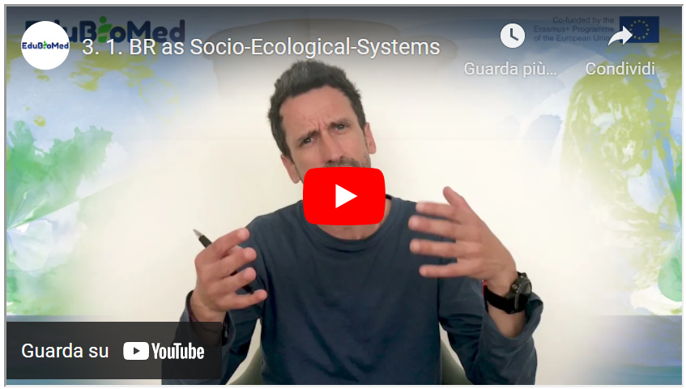
Link to video: https://youtu.be/ZUGpFAPuVDk
Suggested Reading
Adaptive governance of social-ecological systems, Folke et al. (2005).
Transcript of the video
Good morning. So, what is a Social-ecological system (SES)? A SES is a biophysical unit together with its people and social groups and, of course, its cultural practices. So, a Social-ecological system has within it this idea of an embeddedness. So, we're talking about the merging of the physical, the ecological components of the world with the social components of the world and the cultural component as well.
There is another important property in Social-ecological systems, which is interconnection. These components that I just mentioned, the social and the ecological, the cultural and social are interconnected with each other. And because of such interconnection a Social-ecological system is a complex reality because these components interact with each other continuously. This takes me to the second property of Social-ecological systems. They are not monolithic. They change over time. They change over time because the ecology changes, but also because society changes and both can change at the same time. They are in transition. Social-ecological systems change over time. Some scholars have identified six principles of Social-ecological systems or six characteristics.
The first one is that Social-ecological systems, as I said before, they are relational, relational means that these components are interconnected, but also the different components within the components are also interconnected. Think about ecosystems, for example, how trees are connected to the soil, how soil is connected to microbiota and how trees are also connected to birds, to mammals and so on and so forth. There are networks of connection, and if we think for a minute about social systems alone, the same applies, right? So, you have people connecting with other people. You have people connecting with different types of actors, governments, NGOs, companies, companies connecting to all companies. Right.
And all of these social actors at the same time are connecting to the ecology that I was mentioning before. Maybe there is a company that exploits trees. And if this exploitation is unsustainable, it might have a negative impact, for example, on mammals or birds and so on. So that's the first characteristic. It's a Social-ecological system. It's relational and it's network based.
The second one is that it's open, it's open and permeable. Right. A Social-ecological system usually, as I will mention later, is defined by boundaries. But these boundaries are permeable. Why? Well, think again about these components within the components. New actors may appear in our Social-ecological systems. Migrants, for example, who come to live in a given territory. Birds that migrate, they are sometimes in the system at some point of the year and some of the times of the year they have migrated elsewhere. Social-ecological systems are context dependent. The ecology, the geology, the physical properties of the unit obviously depend on where this system is located is not the same as Social-ecological systems in the mountains of Morocco than one Social-ecological system in the mountains of Spain, the characteristics of the soil may differ. The type of trees may differ. The type of social actors may differ.
A fourth characteristic is that Social-ecological systems are adaptive. Right? So, the environment changes. For example, as a result of climate change. And then there are there are species within the ecosystem that adapt to these new temperature conditions or to these new rainfall conditions. And the same happens with the social components of our Social-ecological system. We humans have adapted for millennia to changing environmental conditions, but also to changing policies, to changing governments, to changes in the social fabric. Right. So, we adapt to new market opportunities. We adapt to new cultural regulations or cultural rules. So that's a fourth important characteristic. Social-ecological systems are adaptive.
Finally, they can be, as I said before, dynamic but importantly non-linear. There might be changes in the system which are abrupt that may occur in a very short period of time. And that then may involve that some of these components that I was talking about, the ecology or maybe some social actors may not be able to adapt to such non-linear changes. Think, for example, about recurrent drought. What would be the effects of recurrent draws on the trees or the ecology of that given system? Maybe the drought is so severe and so recurrent that there are some species that simply disappear. Right. So, we are not saying that the Social-ecological system would disappear, but some elements of it would disappear and would be probably substituted by others. And the same applies if you think about the social system were, for example, changing market conditions. If there are changes in the pattern of demand over certain natural resources, for example, there might be some social actors in disadvantage. They might not be able to adapt to these new markets, to these new patterns of demand, and would simply have to reinvent themselves.
And the final characteristic is that within all these relations that exist across components and within the components of each component, the ecosystem, the geology of these given unit, the social system, there are complex processes of causality. So, if, for instance, we observe changes in the in the ecology of a given Social-ecological system, it's very likely that there is no one single cause of such change. There might be different elements or different processes influencing or determining such change. We talk about complex causality within Social-ecological systems.
And again, if I have to give an example, for example, I will go back to trees and imagine a situation where trees in a given Social-ecological system are increasingly being locked. OK, so deforestation is proceeding apace. What are the causes of such deforestation? There might be proximate causes by local actors. We live in the system that are exploiting the trees, but there might be distant causes as well, which is, for example, a growing demand of such type of trees in international markets. And it's about this growing demand that local actors are responding to. So here, if we want to regulate the logging of trees in this given socio ecological system, we obviously need to work with local actors. But we also need to think about, for example, sustainability standards in the international market. And this is, of course, a complex thing to do. And this is why we talk about complexity and complex causality in Social-ecological systems.
If the capsule results too long, we can think of splitting it into two capsules in this point.
So, after this kind of long introduction, probably you've been all thinking, OK, so are biosphere reserves are socio ecological systems? And I hope that all the points I've made resonated to you in one way or another as users of biosphere reserves, as inhabitants of biosphere reserves, as managers of biosphere reserves. I'm sure that you've been thinking that most of the issues I referred to are issues that can also be reflected in the realities of biosphere reserves around the world. Biosphere reserves are indeed a Social-ecological system because they have these defined unit. They have these defined territorial boundaries. These territorial boundaries define what is the ecological system or systems that are included in the biosphere reserve. What type of forest, what type of grasslands? What type of agricultural landscapes? What type of soils? Right. Let's not forget about the then the non-living part of the environment. It's also very important because without it we wouldn't have the ecosystems that we then see and observe.
And then of course, we have the people who live in the biosphere reserves in the outskirts of the biosphere reserve. We will talk about permeability afterwards. And also, of course, the actors who live within it or even the actors who don't live within it, but that have an important role in determining regulations. What can be done and what cannot be done within the Biosphere Reserve. In terms of, for example, natural resource management or agricultural practices and this is very important in biosphere reserves. Biosphere reserves are per se an institution. They determine certain ways of managing the environment that at the same time determine those complex relations that I was talking about before. Right. So, the regulations that the biosphere reserve imposes on the people who live and who make use of the resources within the reserve have consequences on which relationships are established and what can or cannot be done with resources.
Of course, I mentioned before that Social-ecological systems are dynamic, they can change. So, regulations in biosphere reserves could also change. Could adapt to changes in the environment. In the living and non-living environment, but they could also change as a result to changes in society, to changes in culture. What if local actors, local people who live in the reserve have an idea about a new crop to be grown and they are thinking about deforesting. Should they deforest? Or not? The rules may say they cannot deforest. But can these rules be changed? What would determine change? Is it legitimate to ask for changes in the institutions that govern biosphere reserves so that local actors can make a different use of their resources? This is a question that deserves to be asked not only in biosphere reserves, but in any other kind of conservation institution or conservation practice, because societies are dynamic and so is the environment. Often regulations about conservation are focused on resources as they were when the Biosphere Reserve was established maybe 20 years ago. Are those resources is still there? Are they, for example, a as a result of climate change diminishing in quantity, in quality? Does it still make sense to protect those resources? Or maybe they're going be lost anyway as a result of, you know, these global phenomena known as climate change. These are these are questions that socio ecological systems and particularly biosphere reserves should be asking all the time.
Whatever happens within a biosphere reserve, as I mentioned before, needs to be analyzed very. I would say with care, right? What I mean is not if I talked before about complex causality. This is something to take into account when we think about patterns of resource use and conservation within biosphere reserves. Who is to blame for certain practices that may go against the interest of the managers of their reserve? Maybe there is no one single actor to blame or the actor to be blamed is no local actor, but an actor sitting very, very far away of the Biosphere Reserve.
I would like to finish reflecting also on these two other ideas that I mentioned before, one is this idea of relationality. So, thinking about the fact that all actors within the Biosphere Reserve are somewhat connected to each other and that at that same time these actors are connected to resources through different practices, through different cultural understandings of nature, and that all of these different connections are to be taken into account when we think about how to manage a biosphere reserve or what we want to make out of their resources within our biosphere reserve.
And finally, I will end up with this idea of adaptiveness. Biosphere reserves, the ecosystems within it will adapt to changing global environmental conditions. And reserve managers need to be aware of that. They need to be constantly monitoring the state of the state of the environment. Not necessarily to enforce further regulations to avoid changes, but to accommodate changes so it works for the benefit of the actors who live out of these resources.
And finally, in the same way that managers can adapt their expectation about resource use also local actors may need to adapt to changing priorities within the Biosphere reserve and of course, to the changing needs of the broader society where these biosphere reserves are located. And here what I have in mind is how Biosphere reserves for example may adapt to changes in demand of local tourism, for example. With the global COVID pandemic we are seeing for example –at least in Spain but I presume this is the same in other parts of Northern Africa and Morocco as well- where we have increasing number of national tourisms within protected areas. And this type of tourism may have some needs and some priorities which are different than for example international tourism. How then these biosphere reserves can adapt to such changing priorities and these changing needs? It's a question worth asking in the time of COVID.
Well, I hope my reflections were useful, they were maybe too abstract, so what I would recommend you to do is to is that you think about these issues through the lens of your own biosphere reserve, the biosphere reserve you like walking in the biosphere reserve where you live in, or the biosphere reserve that you manage. Thank you very much.

M3 – Lesson #2 Conflicts over the commons
Pablo Dominguez, Universitat Autònoma de Barcelona
Pablo Domínguez, PhD, is an Eco-Anthropologist of the commons, especially centered on pastoral commons of the Mediterranean mountains. He mostly focuses on the ecological and socio-cultural holistic understanding of their functioning. Pablo is Senior Researcher at CNRS (France); Laboratoire Géographie de l’Environnement (GEODE), CNRS / Université de Toulouse 2; Associate Research Fellow at LASEG & AHCISP, UAB (Barcelona); Associate Research Fellow at LPED (Marseille) and LMI MediTer (Marrakech), IRD / Aix-Marseille Université.

Description
In this capsule, Pablo will tell us how Mediterranean Biosphere Reserves can contain traditional cultural practices for the sustainable management of the territories called as ‘commons’ – and how these are threatened in the past, and nowadays.

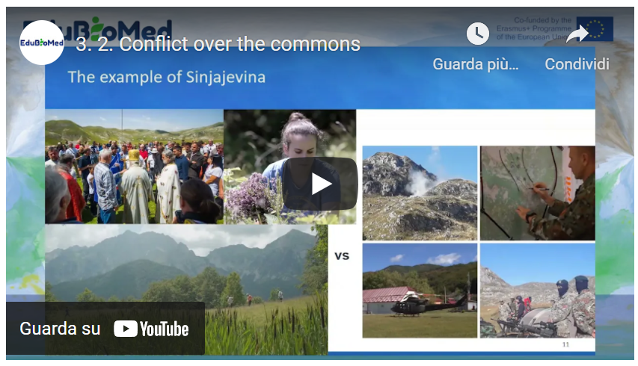
Link to video: https://youtu.be/FhN98nwGAQE

Activity
Learn more about the Sinjajevina case.
Transcript of the video
Hello, my name is Pablo Dominguez, anthropologist of the French National Council for Scientific Research (CNRS). And today, 18th of November 2020, I'm going to give a talk about pastoral community conserved areas in the mountains of the Mediterranean and the case of Sinjaejevina. Mediterranean mountain pastoral commons at the same time a natural and cultural subject, their ever-evolving pasturelands conserved by local populations through dynamic adaptive community governance systems. Mountain populations governing the commons have generally a strong bond with tradition, which is most usually linked to the conservation of the ecosystems and natural resources, as their survival most often directly depends upon them and which they are deeply culturally connected with. In strict economic terms, these comments generally involve assemblies of pastoralists that impose the limitation of access to pastoral space during spring to allow the vegetation to rest at a particularly sensitive period when exponential plant growth, flowering and green production are happening and ensuring so the pastures recycling and sustained use year after year at the same time as maximizing their production while minimizing social conflicts between users due to the high participation of right holders in the management of these ecosystems. Commons are spread practically in all the mountains of the Mediterranean, and we can assume that there are hundreds of thousands of commons in this region and that they could cover more than half a million square kilometers, giving them therefore a huge spatial weight concerning the management of key and very sensitive mountain landscapes that are mostly ignored partially by science and especially by decision makers. Ecologically speaking, community based management results most often in maintaining a denser and better preserve plant cover and free open access lands, biodiversity is often also more important in this commons or has a particularly one authored a small scale and an epic scale of commons. At the same time, they also favor pools for seed conservation diffusion so unrepentant against that ocean availability of water, carbon sinks against climate change, and a great diversity of landscapes, among others.

As a result, even though they are still poorly integrated in international policies and state legal systems, the concept of the Commons is now included in the political decisions and initiatives of some of the most important organizations at the global scale, such as the Convention for Biological Diversity, International Union for the Conservation of Nature, the United Nations Development Program and the United Nations Environmental Program. But it is impossible to know the exact special range of these systems as much as their precise environmental, social, cultural and economic impact, unless a major comparative research on this system is launched at a Mediterranean scale. A large funding is needed for a comparative study of mountain pastoral commons across the Mediterranean, determine exactly their value in terms of biodiversity conservation, ecosystem services, fighting global warming, sustainable development and so forth, with the aim of establishing an audit plan for the support at the regional scale of the whole basin.

At the same time when there is data on social ecological interests, the rural commons in the Mediterranean, actions must be urgently launched in their favor because these systems are eroding very quickly while they will be practically unrecoverable if we do not get to them on time and thus losing forever a living heritage several times millenary that once touched upon practically all Mediterranean landscapes. They are part of our history, our identity, our biodiversity, our past and present ecosystems that we cannot allow ourselves to lose. In fact, this interesting systems, socially and ecologically speaking, are practically all threatened. This is the case since the dawn of time. We're all Moroccan, Spanish, Italian, Montenegrin common studied by myself and colleagues. Moreover, the enclosure of the commons in the Mediterranean mountains seems systematic and not only a question of the past, but very actual.

Let's take the concrete example of Sinjajevina, a cluster of pastoral commons in Montenegro that we have also started to study in depth. The biggest mountain pass through the Balkans, the second in Europe, and a vital ecosystem against climate change that particularly favors biodiversity conservation. In 2019 last year, the government of Montenegro, supported by NATO, decided to inaugurate the military training ground in Sinjajevina within the Tara River Basin Biosphere Reserve next to two UNESCO World Heritage sites, a protected Natura 2000 area where the protection of birds habitats and a regional park for the protection of nature and culture that was supposed to be inaugurated in 2020 - but we're still waiting - unconcerned about the damage this would represent to its people, their traditional uses, and to these social, ecological invaluable systems built by humans and nature through millennia. Is especially astonishing when taking into account the artillery testing ground has been inaugurated without any publicly available environmental impact assessment, health evaluation, economic impact study nor any substantial negotiation with the affected pastoral communities on Montenegro is in accession talks of the EU, where things are usually done all the other way around. The inauguration of this military ground stands as an example of the types of threats many commons in the Mediterranean basin are facing still today in a generalized context where these systems and their customary laws are not acknowledged by the states, which most often consider the lands and resources within this commons as public property and not the local communities’ who are there using them and that have generally enjoyed them for centuries, since the widespread degradation of rural commons in other Mediterranean countries. At the same time, their importance for global and regional ecological sustainability. It is obvious, urgent to address them and to work to protect them and promote them, meaning that Sinjajevina case is important for itself, but also much more as an indicator of a greater degradation phenomenon and lack of recognition to these systems at the Mediterranean and in fact, also at a global scale. Thank you very much for any questions, any reactions. You may just feel free to contact me on the email address you see in the first slide of the of the of the show. Thank you very much.

M3 – Lesson #3 Patrimonialization of heritage
Said Boujrouf, Cadi Ayyad University
Saïd Boujrouf, professor of geography and director of the Laboratory for Studies on Resources, Mobility and Attractiveness (LERMA) at Cadi Ayyad University in Marrakech-Morocco. Interested in territorial planning, territorial development, patrimonialization and touristic valorization. His researches also concerned governance and innovation in Moroccan context.

Description
How can heritage be enhanced for sustainable territorial development? Second, are biosphere reserves a tool for heritage development? Thirdly, could patrimonialization contribute to the preservation and resilience of biosphere reserves? Professor Boujrouf will address this question using the case of the Arganaraie Biosphere Reserve in Morocco.
Link to video: https://youtu.be/UtwkXCkKL8s
Activity
Read about the Réserve de Biosphère des Arganeraies.
Read about the scientific field trip of UCA teachers and students.
Watch the video about the scientific field trip of UCA teachers and students.
Further Readings
Benhsain, Wafaa & Boujrouf, Said. (2020). Territoire labellisé, enjeux et contraintes pour un développement et une attractivité touristique, cas du Patrimoine mondial de l’UNESCO.
Dubeuf, Jean-Paul & Boujrouf, Said & Romagny, B & Alifriqui, Mohamed. (2021). Les visions et référentiels des politiques de développement territorial dans l’arganeraie : retour sur 10 ans d’initiatives et de projets -2019.
Tebaa, Ouidad & Boujrouf, Said. (2019). Patrimonialization and the Geopark Label: for Which Development Model in the South? The Case of Morocco. 10.1002/9781119681489.ch4.
Abdollah, Ahmed & Bouaabid, Hanane & Michon, Genevieve & Boujrouf, Said. (2016). Chapitre 16. Tourisme et valorisation des spécificités locales. 10.4000/books.ird éditions.26009.
Auclair, Laurent & Kejjaji, Sana & Michon, Geneviève & Boujrouf, Said & Skounti, Ahmed. (2016). Chapitre 9. Quels processus de patrimonialisation pour la préservation des sites rupestres ?. 10.4000/books.ird éditions.25949.
Boujrouf, Said & Mostafa, Hassani & Dubeuf, Jean-Paul. (2015). La participation des politiques publiques à l’émergence et à la gouvernance des dispositifs de valorisation des produits de terroir : Une analyse croisée des politiques de valorisation des produits de terroir au Maroc et en Corse.
Boujrouf, Said. (2014). Ressources patrimoniales et développement des territoires touristiques dans le Haut Atlas et les régions sud du Maroc. Revue de géographie alpine. 10.4000/rga.2259.

Transcript of the video
Hello Saïd Boujrouf, professor at Cadi Ayyad University and member of the EduBioMed programme. Today, I would like to talk to you about the enhancement of the cultural and natural heritage of biosphere reserves in the case of the Arganeraie Biosphere Reserve in Morocco.
This vignette is part of the MOOC entitled: "Biosphere reserves as living laboratories for sustainability education, applied research and local development". Our initial questions are threefold. Firstly, how can heritage be enhanced for sustainable territorial development? Second, are biosphere reserves a tool for heritage enhancement? Third, could heritage development contribute to the preservation and resilience of biosphere reserves? So, to answer these questions, we have set two main objectives; Starting from the fact that Unesco when it defined biosphere reserves as learning places for sustainable development, among others. For this reason, we are looking for a general objective that can be manifested in the following questions: How can biosphere reserves serve to understand and manage changes in the interactions between social and ecological systems? And how can the enhancement of the biosphere reserve and its heritage contribute to a strong awareness among stakeholders and learners of the role of this reserve in territorial and sustainable development? Thus, biosphere reserves are an open-air laboratory. It helps us to observe, learn, understand and act on sustainable development issues. And of course, we are going to see all this from the case of the Argan Biosphere Reserve (ABR) located in central western Morocco.
So, the ABR is the first biosphere reserve recognised in Morocco by UNESCO in 1998. It was declared as an area that could be preserved and be a conservation area. But, at the same time of human, social and sustainable development. Because it is inhabited by the local population who have the right to exploit the natural resources found in these areas. This reserve covers an area of approximately 2,500,000 hectares. It concerns 8 provinces and prefectures, located in the centre-west of Morocco. It covers a vast intra-mountainous plain, bordered by the High Atlas and Anti-Atlas mountains and the Atlantic Ocean in its western part. Thus, it reaches an altitude of 2,500 metres and is part of the Saharan Mediterranean transition zone established around a forest species endemic to Morocco called Argania Spinosa, the main characteristic of the Moroccan sector with a vegetation of Mediterranean forests, woods and scrub. This biosphere reserve extends from the Essaouira region in the north to the Sidi Ifni region, Guelmim in the south and as far as Tafraoute in the east and the Tata region. This large area of the RBA recognises the singularity of the production system and the potential of biodiversity combined with a specific cultural identity. This is a situation for which sustainable projects are needed.
The main objectives of the creation of the biosphere reserve are as follows: Firstly, the preservation of biological resources, landscape and cultural values. Secondly, to maintain the balance and the ecosystems. And finally, the promotion of environmental education and the contribution to local and regional development in this area of Morocco.
The enhancement of this heritage, which is natural, human, diverse, rich and specific, requires sustainable territorial development in order to make the RBA sustainable. To this end, in order to enhance this heritage, the efforts of the various actors and stakeholders must be combined to ensure an enhancement that brings several elements and several important results for the sustainability and the social, human and sustainable development of the reserve and the local population. Firstly, the well-being of the population within the framework of an inclusive human and social development. Secondly, a sustainable development of biodiversity in a sense that integrates the economic aspects related to the life of the local population. Thirdly, a construction of the heritage resource on the basis of the specificity linked to the endemism of the argan tree and to the local human treasures, the result of the know-how and life skills of the populations. Fourthly, a better contribution of the biosphere reserve's ecosystem services, as it provides services related to water, wood, agricultural products and crafts with the population. Other services are added that are linked to its resilience, such as the fight against erosion and desertification. Thus, the RBA is a space of conciliation between man and nature. A space that offers its natural capital for the promotion of sustainable solutions, especially the resilient tree that is the argan tree. Therefore, enhancing the heritage for a sustainable territorial development of the biosphere reserve requires combining the efforts of the different actors and stakeholders to ensure an enhancement that brings in the 5th point, the labelling and certification.
This fifth point should be connected and complementary, ensuring geographical origin, food quality, fair trade and ecotourism, etc. Thus, for the role of labelling in the heritage of the RBA, we can see that the relationship between enhancement and the recognition of the biosphere reserve as a world heritage site emerges as a strong issue and produces economic spin-offs and a real race for 'labelling'. In fact, labelling is becoming a means of justifying the discourse and practices of environmental protection. But also, to reinforce the territorial anchoring and the reconstruction of the resources which become of course patrimonial. In this respect, several labels and certifications are emerging, based on the concepts of ecotourism, ecolabelling, and agricultural and craft certification.
There are at least a dozen labels and certifications that take into account the specificities of the RBA, its heritage and its natural and human capital. So, the role of labelling in the heritage of the Argan Biosphere Reserve is important, but we must pay close attention to the developments that are beginning to take place in the field and that we have noticed in a certain number of field surveys, especially in the city of Agadir. Although general or specific labelling contributes to the construction of a territory brand and a local identity, we must be careful about the trivialisation that could affect the specification system and risk eroding its constructs. For example, the idea that labels for local products protect local knowledge and specificities needs to be demonstrated; especially, on the one hand, with the few deviations that are beginning to be noticed in the different places and territories of the biosphere reserve. On the other hand, noticed in the urban space and noticed, essentially, in the markets.
Another important aspect, which makes the valorisation and patrimonialisation help the sustainable development of these specific territories, is the recent recognition of the International Day of the Argan Tree by the United Nations.
This is another way of raising awareness, education and heritage of the RBA, which promoted an international day of the argan tree, on May 10 of each year. The year 2021 was the first day to celebrate this tree which is the argan tree, presents not only natural endemism, but also a whole human, cultural and identity heritage behind; Thus, how this resilient tree that can cope with difficulties and climate change, but also fight against desertification, degradation of the environments of this vast territory. Thus, this International Argan Day is another way of raising awareness, educating and making the biosphere reserve a heritage site.
Promoting heritage for sustainable territorial development of the biosphere reserve also involves promoting tourism, which is an important aspect of heritage development. In the context of the RBA, this tourism development is carried out in connection with a tourist hub, the city of Agadir. At the beginning, tourism in the RBA seeks to diversify the offer of the tourist city of Agadir with approximately one million tourists in 2015, of which more than 95% of tourists are mainly targeting the seaside. Tourism in the hinterland of Agadir is small, accompanied mainly by small rural accommodation structures with an essentially itinerant tourism.
At the same time, eco-tourism is beginning to mobilise the heritage resources linked to the biosphere reserve and which involves crafts, cultural art, gastronomy, identity and local products, etc., with a real start to raising awareness of the sustainable development of the biosphere reserve, with a concretisation of the biosphere reserve concept by means of labelling, certification and conciliation between the needs of the population and the need to conserve the natural capital. A diversity, therefore, of local, regional, national and international stakeholders who come to carry out preservation projects, but also human development projects in these territories of the RBA. These territories are fragile, specific and are the breeding ground for a new territorial construction that seeks to establish a local ecotourism adapted to the environment of the biosphere reserve. But the stakeholder system still needs a specific governance adapted to this biosphere reserve situation. It needs connectivity, communication, building bridges of negotiation, coordination between the different stakeholders, sharing and ways of sharing. As well as, ways of sharing the heritage resources of this territory equitably. This means being able to move towards a territory project and not project territories, which we are currently seeing develop. Of course, this territory of the reserve or these territories of the RBA, seen from the tourism side, is made up of several territories.
Firstly, Agadir, Ida Ou Tanane and lnzegane Ait Melloul, the Chtouka Ait Baha, Taroudante, Tata and Tiznit with the construction either in the sense of preservation and ecotourism; or in the diversification of the offer of the city of Agadir. There are at least 7 major tourist routes; the honey route, the Igoudars route, the route linking the Atlantic to the Anti-Atlas, the orange routes, the Mesguinas route, the Atlantic coastline route and which touches on the Souss-Massa National Park (PNSM), as the last product or the last space for practising ecotourism. There are initiatives, for example, that of the Rural Tourism Development Network (RDTR), which builds tourist circuits around the problem of the biosphere reserve by linking the heritage sites with the diversified landscape linked to the relief and the argan forest. As well as, the sites of the production of local products by criss-crossing the plain areas, the mountain areas, the Piedmont, the mountains of the High Atlas and the mountains of the Anti-Atlas going as far as the Saharan border open to the regions of Guelmim and Tata. If we take a map of tourism in the RBA region, we find that there is a well-developed tourism which is essentially established in the city in the urban area, while on the other hand there is still a timid tourism, linked to rural and ecotourism, in these diversified regions, with territories which can be complementary in the tourist offer, but there is still a lot of work to be done in this direction.
Lastly, to enhance the value of the heritage for sustainable territorial development and to ensure that the patrimonialization that is underway will contribute to the sustainability of the biosphere reserve. To do this, we see that we should move up a gear and set up a system of payment for ecosystem services (PES). We know that Morocco has launched a project with the UNDP called "Circular Economy Approaches for the Conservation of Agro-Biodiversity in the Souss-Massa Region", in the Arganeraie Biosphere Reserve, which is the result of this cooperation between Morocco and the UNDP. However, in order to achieve this goal, which is payment for ecosystem services, it is necessary to use this innovative instrument for the preservation of "nature" capital, which should be integrated into public and private accounting in our country.
Valorisation involves the labelling and marketing of two local products, namely argan oil and honey, which will help to mobilise natural and human capital in a market context. Will we be able, through these choices and orientations, to ultimately face the weakness of the resilience and fragility of the environment of the RBA and the needs of the local population, for the development of their goods and their well-being? Can we, in this way, achieve territorial and sustainable development? And also as a hope, to honour Morocco's commitments to UNESCO, to the local population and to everyone who loves nature and would like to preserve its territories of sustainability and endemism, and even of cultural specificities and identities such as the Arganeraie Biosphere Reserve.

M3 – Lesson #4.1 Territorial governance in Biosphere Reserves
Catherine Cibien, MAB France
Catherine Cibien is the Director of MAB France. MAB France animates and strengthens the national network of 14 Biosphere Reserves, puts it in touch with the French and international communities interested in this program: scientific community, educational and academic world, organizations for the management and conservation of biodiversity, sustainable development and of the ecological transition. She co-hosts the Master MAB (Man and Biosphere) at the University of Toulouse.

Description
In this capsule, Catherine will provide an overview of the overarching arrangements that constitute the governance of a Biosphere Reserve.

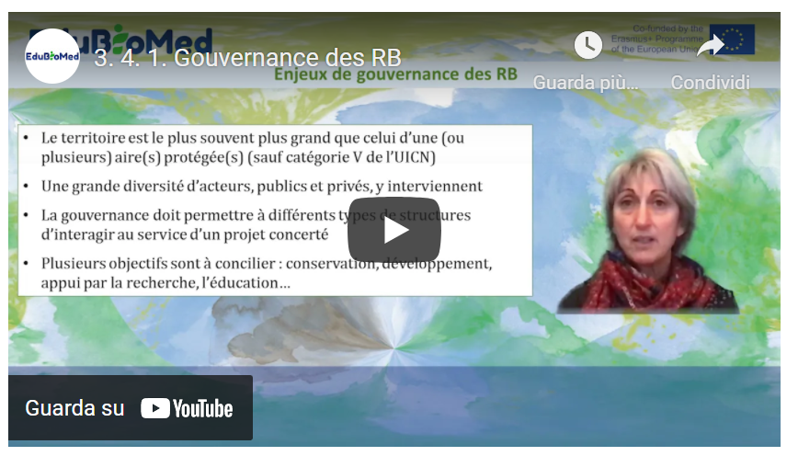
Link to video: https://youtu.be/U1-LKBbn9O8

PPT presentation
Link to the slides: https://www.edubiomed.eu/wp-content/uploads/2021/09/PPT-4.1-Module-3.pdf

Further Readings
Stratégie de Séville et cadre statutaire du réseau mondial. UNESCO 1996.
A New Roadmap for the Man and the Biosphere (MAB) Programme and its World Network of Biosphere Reserves 2015-2025. UNESCO 2016.

Transcript of the video
The governance of biosphere reserves was clarified at the Seville conference in 1995, particularly through the texts that are still relevant for the implementation of biosphere reserves. Biosphere reserves are not protected areas, but are more than protected areas. They integrate them, but with the vision of integrating conservation into the sustainable development of populations. The statutory framework governing biosphere reserves, which dates back to the Seville conference, sets out the provisions relating to governance in Article 4, and specifies that measures must be taken to involve and associate a set of stakeholders who are representative of the territory in which the biosphere reserve is located. The public authorities, administrations, and therefore elected representatives, local communities and also private interests: companies, associations, associations with an interest in the environment, cultural associations, etc. Both public and private interests will be associated at the time of the creation of the biosphere reserve and throughout its life and the implementation of its management.
It is therefore necessary to provide, in addition to this broad and open governance which may take the form of a management committee, resource use management mechanisms for the buffer zone where not everything is allowed and the buffer zone.
Activities must be controlled in one way or another, and therefore must have management mechanisms in place. But the whole biosphere reserve, and therefore all three areas that make it up, must have a management plan or policy. Of course, this management policy must be put in order and periodically renewed. Usually every ten years, and it will therefore need an authority or a mechanism to implement this management policy.
Also recall that the biosphere reserve must develop research programmes and environmental monitoring programmes, education, training and awareness-raising programmes. It should also be recalled that the core areas of biosphere reserves are protected areas established by law and their objective is long-term conservation. The biosphere reserve is more than a protected area, but it contains protected areas.
Then, it should be noted that the territory itself can sometimes be a protected area which will be category 5 or 6 in the IUCN categories. May contain several protected areas, sometimes several different types of protected areas, for example in France, a nature reserve and a biotope protection decree, and a piece of land that will be under land protection that will belong, for example, to the Conservatoire du Littoral (Coastal Protection Agency).

A biosphere reserve is a territory where a wide variety of stakeholders, both public and private, are involved. We must always keep in mind that several objectives have to be reconciled and therefore different types of public and private structures will be called upon to interact, but they will interact within the framework of a concerted project. The objective of this governance and the establishment and animation of this concerted project. As several types of statues are present in biosphere reserves. It will be necessary to make them consistent. In other words, the work of the biosphere reserve and this governance will serve to coordinate, animate, implement and mobilize different types of stakeholders and, of course, sometimes to deal with complex situations. They are obviously not absent.
Conflicts between interest groups who may have a different vision of the future of the territory and who will need to be brought into dialogue, to discuss conflicts over land use, over the use of resources, sometimes from different points of view within the local population, but sometimes between the local population and governments further away from the field. Conflicts also arise between production and the economy and conservation. These are all conflicts that the biosphere reserve will have to manage and will be keen to manage.
It is obvious that information and communication are important in all this. Transparency regarding the decisions taken and the associated stakeholders, local participation is very much encouraged in biosphere reserves and different types of animation techniques are required. Therefore, all these points relating to communication, dissemination and mediation are absolutely fundamental.
The way in which biosphere reserves are organized varies a lot from one case to another and on a global scale. There are obviously different types of models that implement governance.
In some countries, there is a model called authorities, according to work done by the German Commission for UNESCO, which notes that in some cases, the state is in charge of the management of biosphere reserves, sometimes only the core areas. And in these cases, it is obvious that the State is poorly equipped and has little or no competence for local development, and therefore has a weakness. From this point of view. Often, it is the oldest biosphere reserves which were based on this type of governance model. There are also much more flexible models that the German Commission for UNESCO has called the NGO Model Coordination Model. It is a model that is more based on cooperation, a coordination function, but often limited means of management and implementation, means of intervention, land management or land use. On the other hand, these structures make it possible to fluidify dialogue at the territorial level, to make it possible and they are present in different countries. And then, of course, there are many mixed models. In France, there are many different types of arrangements, but most of them are mixed models or rather coordinated models, but nevertheless with a mix. Among the mixed models we have two biosphere reserves which are supported by national parks. The national parks in France have been adapted following a relatively recent law dating from 2006 which provides for a core area of the park which is regulated, but which is integrated into a zone of free adhesion of local authorities and whose objective will be a sustainable development project around the core of the park in a notion of ecological solidarity, solidarity between the core and the zone of adhesion, therefore a balance between conservation and development and a balance which aims to be reinforced by solidarity mechanisms. The two biosphere reserves based on this system have the same governance as the national park, with a board of directors comprising a majority of local authorities, representatives of local communities, but also the administration, representatives of the main activities of the territory, foresters, farmers, representatives of farmers, and representatives of the private sector.
And who can of course sit in thematic and specialized committees, but also have the right to take decisions at the time of the board of directors. This board is also supported by an economic, social and cultural council and a scientific committee.
Among the biosphere reserves that operate according to the co-coordination model, there are different supporting structures that can be alone or in connection with other communities. And in these cases, when there are several types of structures that support a single biosphere reserve, the biosphere reserve serves as a cooperation mechanism between different entities on the scale of a territory that has ecological, social or cultural coherence. And there, there are different possibilities: a watershed management institution as in the Dordogne, mixed syndicates, mixed syndicates of regional nature parks alone or with other mixed syndicates, or other types of community codes such as conurbation communities when a town is part of the biosphere reserve territory. Or a marine nature park, as is the case in the biosphere reserve in Brittany. Thus, there is a wide variety of arrangements that enable the biosphere reserve to adapt as well as possible to the implementation of these three functions of conservation, development support and logistical support on the scale of a territory that is an entity in ecological, social and generally cultural terms.

M3 – Lesson #4.2 Territorial governance in Biosphere Reserves. The case of Morocco
Lahoucine Amzil, University Mohammed V
Full professor of Geography / Co-Coordinator of Master program on tourism, sustainable development and land management. University Mohammed V, Rabat – Member of several national and international research groups aligned with the scope of Edu-BioMed project – Research team on the Region and Regionalization (E3R) – Centre for Research and Geographical Studies (CERGEO) – LITOPAD/UM5R team – LMI-MediTer/IRD. He is conducting a research project named: “Man and mobility: new identities, new territorialities” in the Arganeraie Biosphere of Southern Morocco M&B.
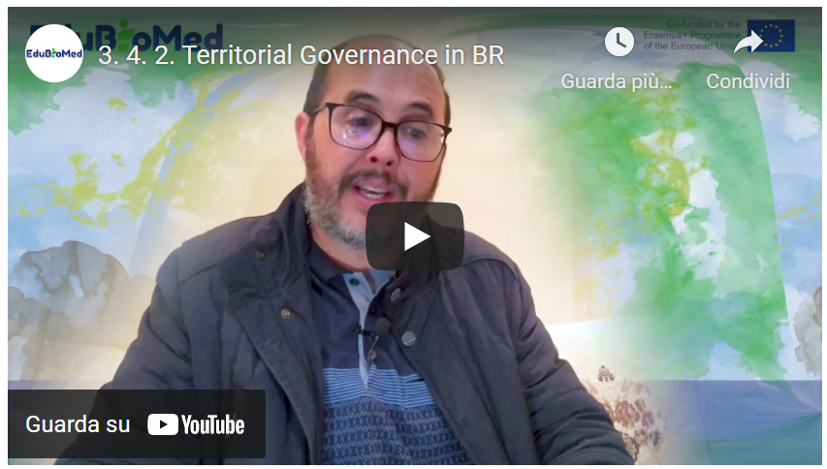
Link to video: https://youtu.be/zvBj1FwnN80

M3 – Lesson #5 Biosphere Reserves and Education
Angela Barthes, University of Aix-Marseille
French Full professor, Department of Education in Social Sciences, Humanities and Management (AMU-ADEF). Projects: Intercultural Education for Environment and Sustainable Development (EIEDD) ANR/FRQC; Rise H2020 “Geoparks: Heritage, Education and Sustainable Development”. Teaching: IUT environment – Geography – Sciences of education. Research topics: Education, Knowledges and territorial development, Sustainable development education, citizenship education, territories education, heritage education, local development, rural development and education.

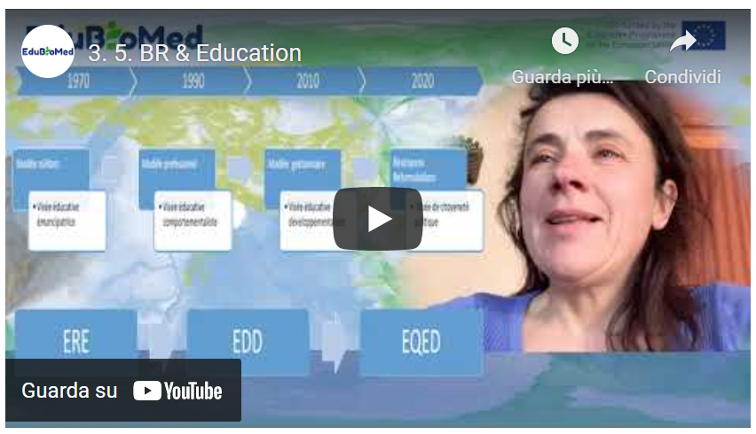
Link to video: https://youtu.be/VCxY4dIfUFk

https://www.edubiomed.eu/?page_id=1620
https://www.edubiomed.eu/wp-content/uploads/2021/09/READING_Adaptive_Governance_of_Social_Ecological.pdf
https://www.landrightsnow.org/get-involved/save-sinjajevina-now/
http://andzoa.ma/fr/andzoa/zone-dintervention/zone-de-larganier/reserve-de-biosphere-des-arganeraies/
http://lerma-flsh.uca.ma/sortie-de-terrain-rba-de-lequipe-du-lerma-uca/
http://lerma-flsh.uca.ma/sortie-de-terrain-rba-de-lequipe-du-lerma-uca/
http://belsp.uqtr.ca/id/eprint/797/1/MAB-UNESCO_1996_Strat%C3%A9gie%20de%20S%C3%A9ville_Cadre%20statutaire_A.pdf
http://www.termeszetvedelem.hu/_user/browser/File/UNESCO/MAB-UNESCO%20dokumentumok/New%20Strategy%20and%20Lima%20Action%20PLan.pdf

